**Practical 9**

**To implement of K-Mean Clustering and Unclustering on Jupyter Notebook using python.**

import matplotlib.pyplot as plt

import pandas as pd

import seaborn as sns

iris = sns.load_dataset('iris')

labels = iris.species.unique()

iris.head() **#Output : Fig.9.1**

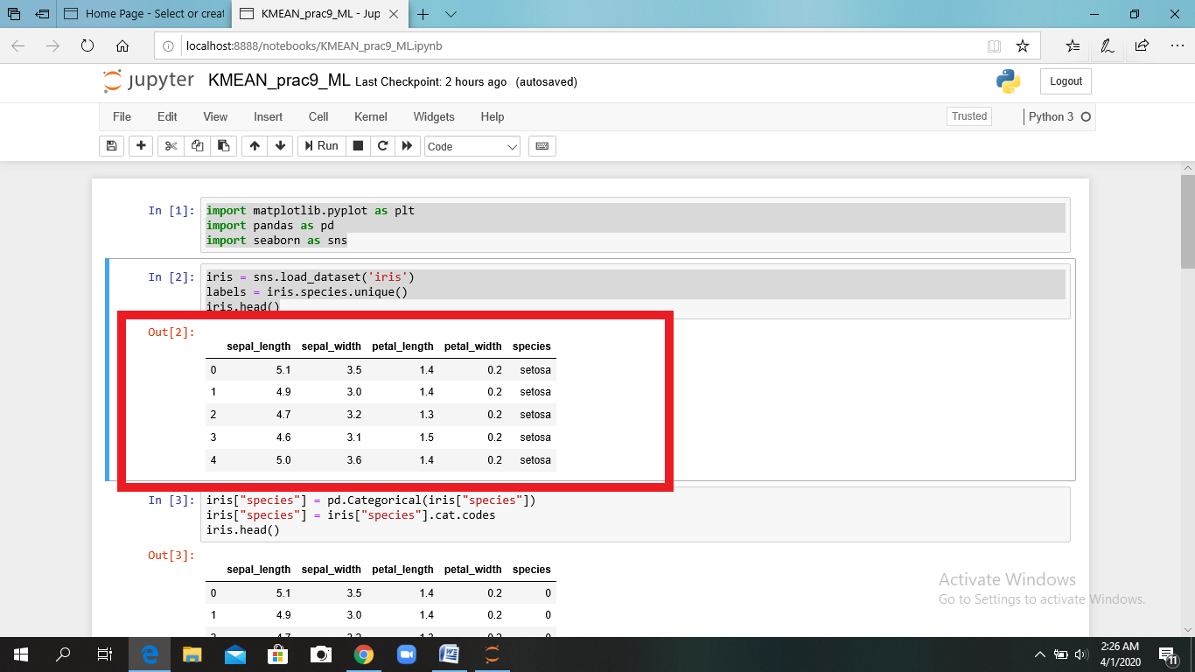

*Fig.9.1 iris.head()*

iris["species"] = pd.Categorical(iris["species"])

iris["species"] = iris["species"].cat.codes

iris.head() **#Output : Fig.9.2**

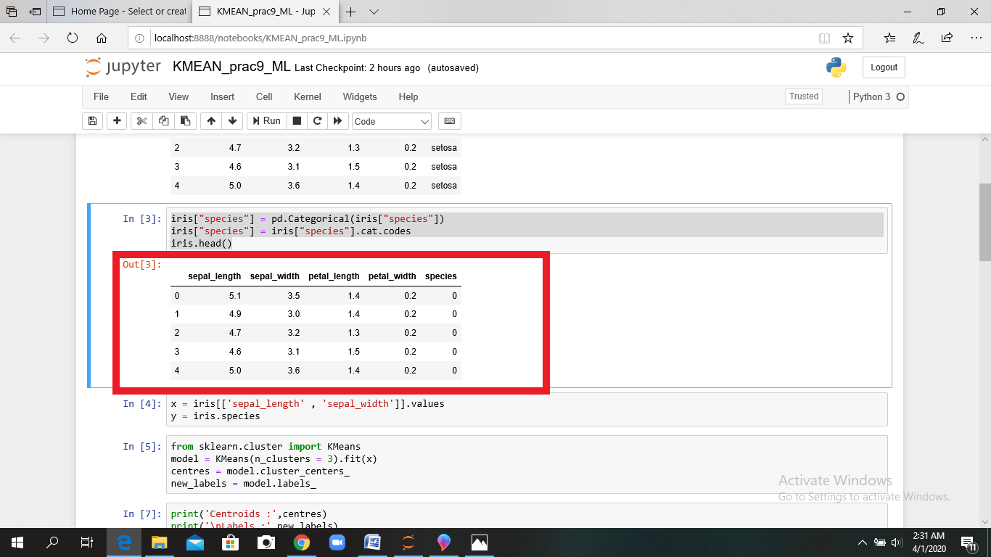

*Fig.9.2 iris.head()*

x = iris[['sepal_length' , 'sepal_width']].values

y = iris.species

from sklearn.cluster import KMeans

model = KMeans(n_clusters = 3).fit(x)

centres = model.cluster_centers_

new_labels = model.labels_

print('Centroids :',centres) **#Output : Fig.9.3**

print('\nLabels :',new_labels) **#Output : Fig.9.3**

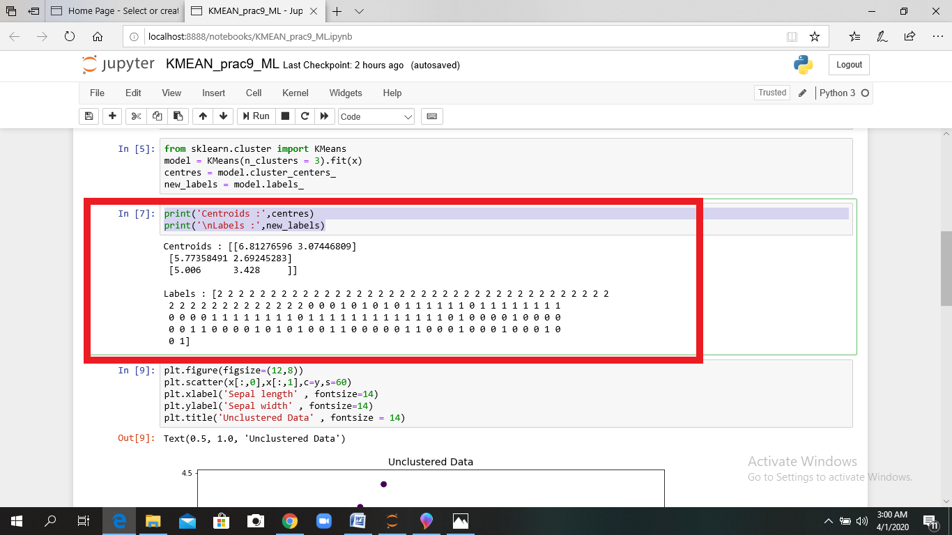

*Fig.9.3 Centroids and Labels*

plt.figure(figsize=(12,8))

plt.scatter(x[:,0],x[:,1],c=y,s=60)

plt.xlabel('Sepal length' , fontsize=14)

plt.ylabel('Sepal width' , fontsize=14)

plt.title('Unclustered Data' , fontsize = 14)  **#Output : Fig.9.4**

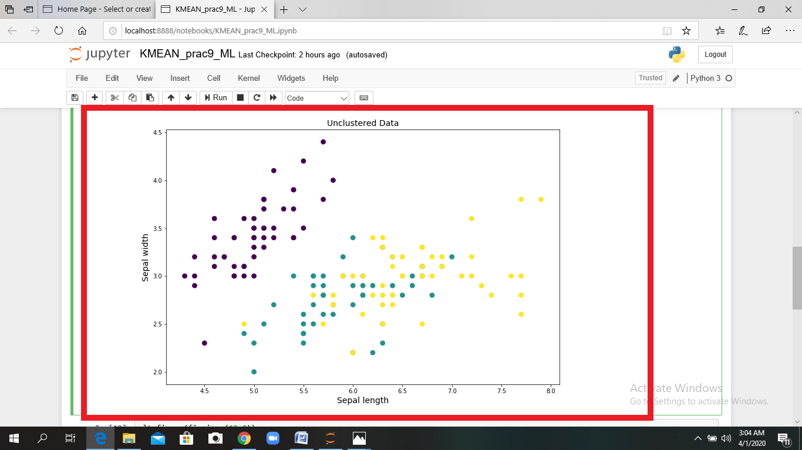

*Fig.9.4 UnClustered Data*

plt.figure(figsize=(12,8))

plt.scatter(x[:,0],x[:,1],c=y,s=60)

plt.scatter(centres[:,0],centres[:,1],c='r',s=400,marker = '*',zorder=10);

plt.xlabel('Sepal length' , fontsize=14)

plt.ylabel('Sepal width' , fontsize=14)

plt.title('Clustered Data' , fontsize = 14) **#Output : Fig.9.5**

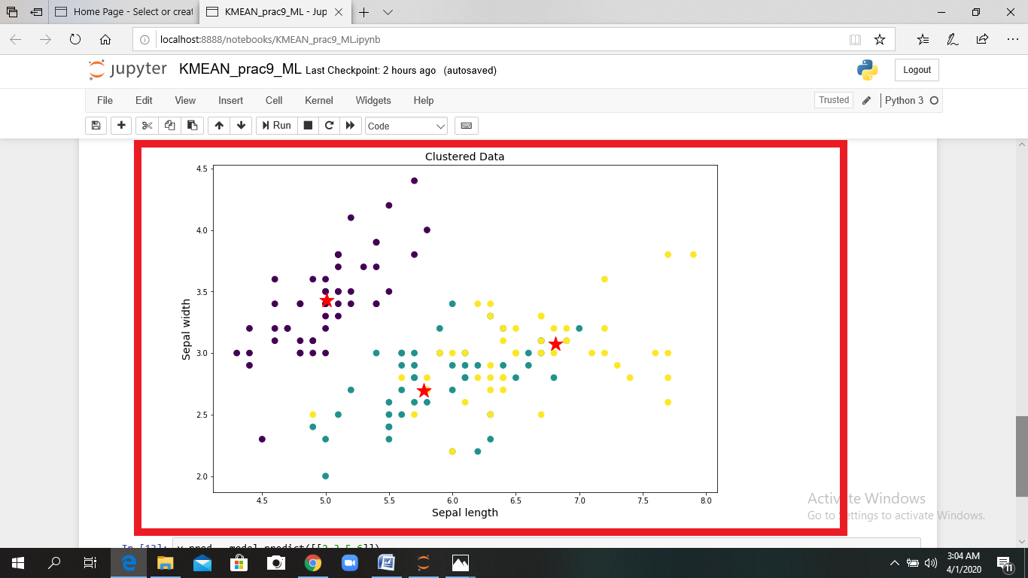

*Fig. 9.5 Clustered Data*

y_pred = model.predict([[2.3,5.6]])

print("Result :",labels[y_pred[0]]) **#Output : Fig.9.6**

**Output Result :**

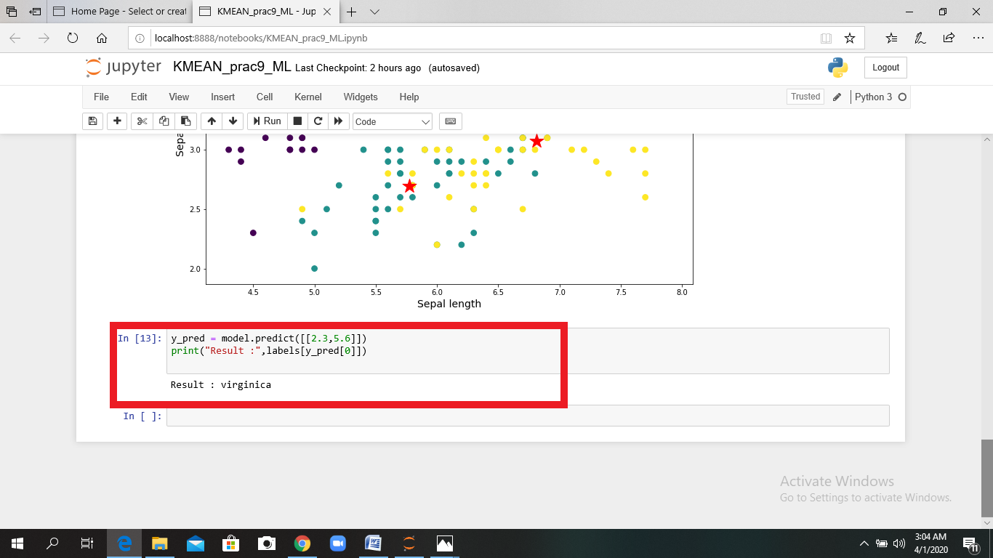

*Fig. 9.6 Result*